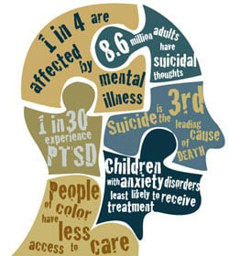**Psychological diseases**

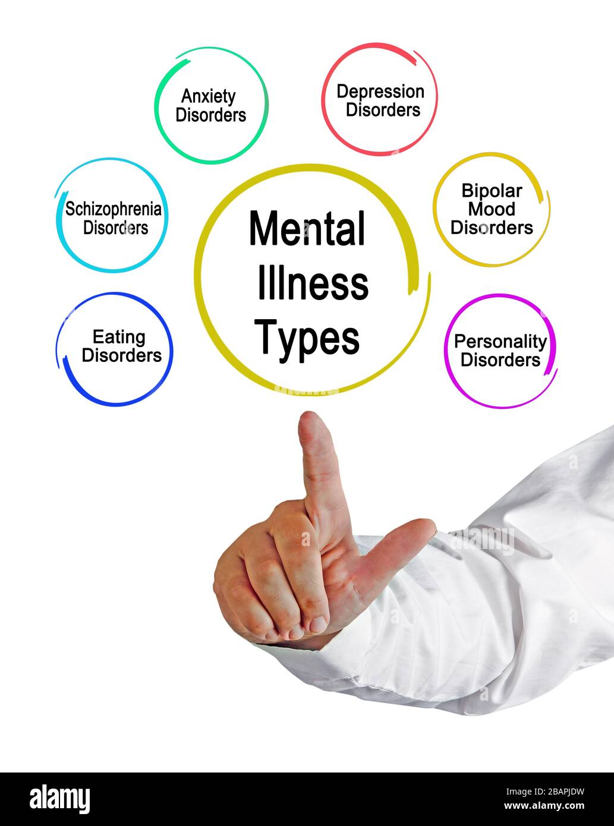**Mental health conditions are one of the major groups of noncommunicable diseases.**

* What are the psychological diseases?
  + depression
  + bipolar disorder
  + schizophrenia
  + psychoses
  + dementia
  + developmental disorders including autism
* Common mental disorder is **Depression**.
* 264 million people are affected in world.

**Reference**

Mental disorders - WHO | World Health Organization - <https://www.who.int/news-room/fact-sheets/detail/mental-disorders>

-------------

**Effects of psychological diseases**

* Examples of effect of psychological diseases
* Excessive fears or worries, or extreme feelings of guilt
* Extreme mood changes of highs and lows
* 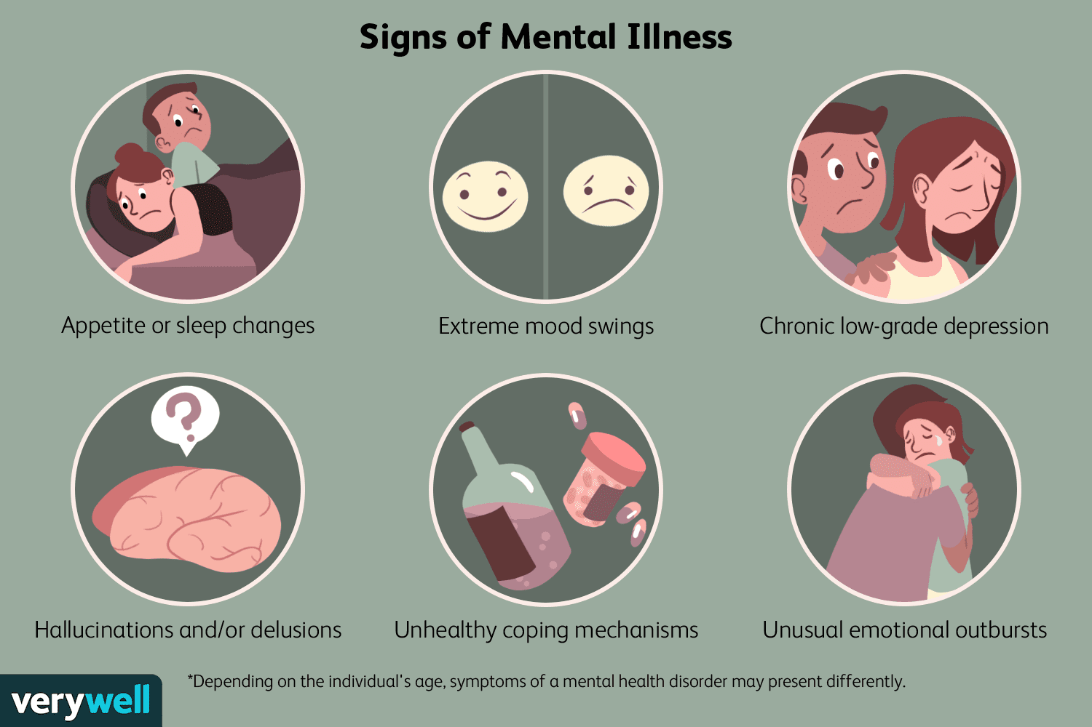stay in away from friends and activities
* Significant tiredness, low energy or problems sleeping
* Excessive anger, hostility, or violence
* Suicidal thinking
* Suiciding is the most dangerous resulting action of these diseases.

**Reference**

"The effects of psychological distress and its interaction ...." <https://www.ncbi.nlm.nih.gov/pmc/articles/PMC5959313/>.

**Ways of combating psychological diseases**

* Talk about your feelings.
* Go outside and travel.
* Get a good night’s sleep.
* Eat well. A balanced diet can improve your sense of wellbeing and your mood.
* Limit Your Time on social media & The News
* 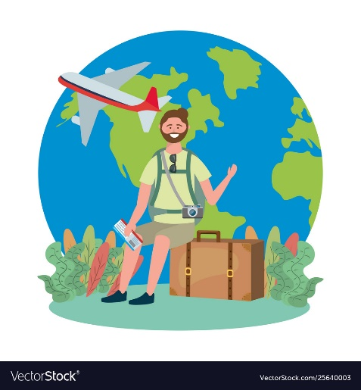Stay active. Physical activity is not only good for your body, it’s great for your mind.
* Stay connected. Supportive friends can help you deal with the stresses of life.
* Care for others. working on relationships with family
* letting go of old grudges or volunteering.
* Channel the one doctor for mental illness.

Reference

"Mental illness - Symptoms and causes - Mayo Clinic." 08 Jun. 2019, <https://www.mayoclinic.org/diseases-conditions/mental-illness/symptoms-causes/syc-20374968>.